Fig. 1. PRISMA flow diagram of study selection
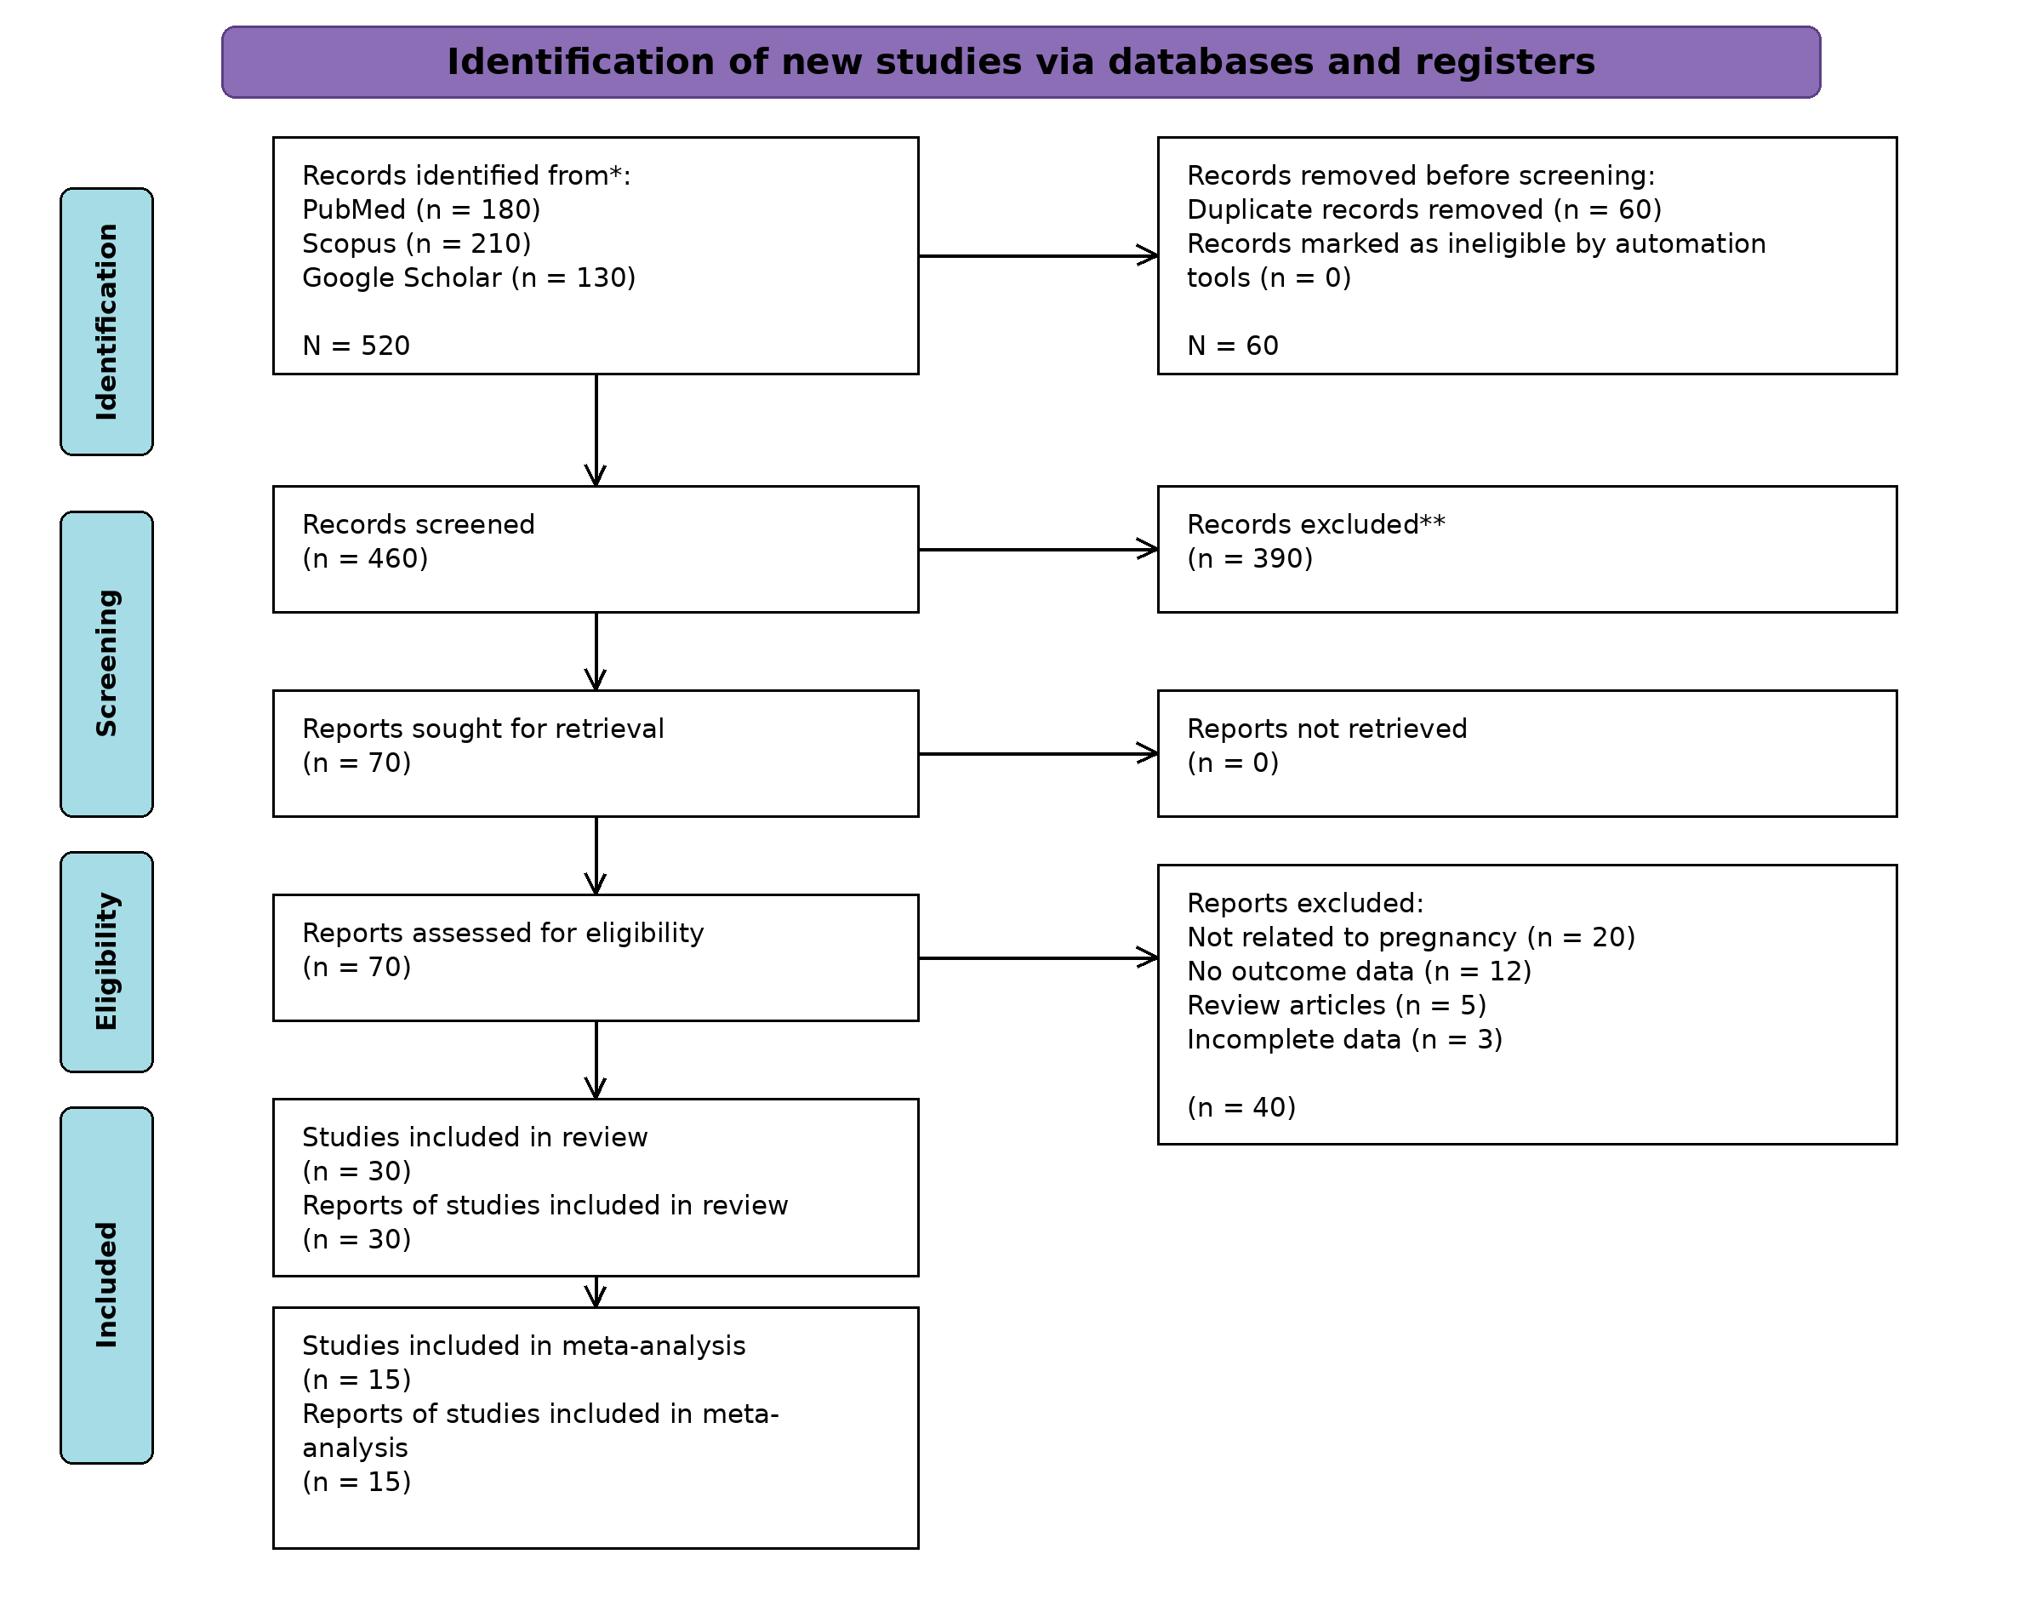
Database search identified 520 records. After duplicate removal and eligibility screening, 30 studies were included in the review and 15 studies were included in the meta-analysis.

